**Disco lights**

## Step 1: Make it

### What is it?

Make your own disco light show with the new micro:bit! The LED lights pulse in time to music picked up by the built-in microphone. The louder the sounds, the brighter they glow.

### What you'll learn

* How to use the new micro:bit's built-in microphone sensor to measure how loud a sound is
* How to vary the brightness of the LED display output in response to sensor input readings

### How it works

* The microphone measures loudness of the sounds it picks up as numbers from 0-255. 0 is the quietest sound, 255 is the loudest.
* All the LEDs on the display are switched on when the program starts.
* The brightness of the LEDs can also be set using numbers from 0-255. 0 is the darkest (off) and 255 is the brightest.
* A loop constantly sets the brightness of LEDs to match the amount of sound picked up by the microphone sensor.
* The louder the sound, the brighter it makes the LEDs shine.
* Flash this program on to a new micro:bit with sound, play some music with a strong beat and watch the lights pulse in time to the music!

### What you need

* new micro:bit with sound (or MakeCode simulator)
* MakeCode or Python editor
* battery pack (optional)

## Step 2: Code it

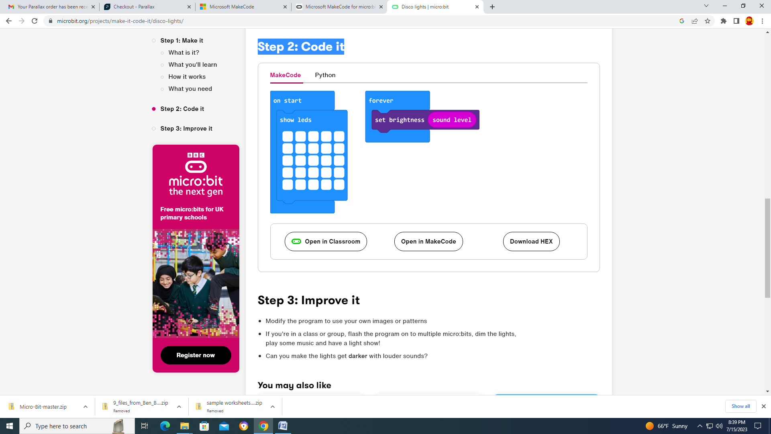

## Step 3: Improve it

* Modify the program to use your own images or patterns
* If you're in a class or group, flash the program on to multiple micro:bits, dim the lights, play some music and have a light show!
* Can you make the lights get **darker** with louder sounds?